TR of V2X SP – Task2

Introduction – Draft group
[Editor’s note: This section introduces overall V2X standards framework in China. The whole picture illustrating SDOs/Industry Alliance in China exampled by QC needs to be updated. And a briefly description for collaboration and focus is also needed]

Key SDOs or Industry Alliances
[Editor’s note: This section introduces the working scope, main role, completed and ongoing V2X related standards etc. of selected typical SDO or alliance in the ICT, automobile, transportation and transportation management industries]

IMT2020(5G)PG C-V2X WG — ZTE/Keysight/Intel

CCSA(Communication) – CATT/QC/ZTE

NTCAS: SC34 (Automobile) –HW/QC/CATT

CSAE/ CAICV : V2X WG (Automobile) -QC
C-SAE (China Society of Automotive Engineers) was founded in 1963, targeting to promote the healthy and sustainable development of China’s automotive industry. At present, C-SAE has more than tens of thousands of individual members and over thousands of corporate members. CAICV (China Industry Innovation Alliance for the Intelligent and Connected Vehicles) was established on June 12, 2017. It is the industry alliance under C-SAE and CAAM (China Association of Automobile Manufacturers) that focuses on the ICV (Intelligent Connected Vehicles) related technology development and industry promotion. The supporting and administrative ministry is the China Ministry of Industry and Information Technology (MIIT). CAICV now owns more than 500 members that cover automotive manufactures, Tier1s/2s, ICT companies, ITS players, universities as well as research institutes. There are 13 WGs under CAICV. Below figure show how it is being organized.

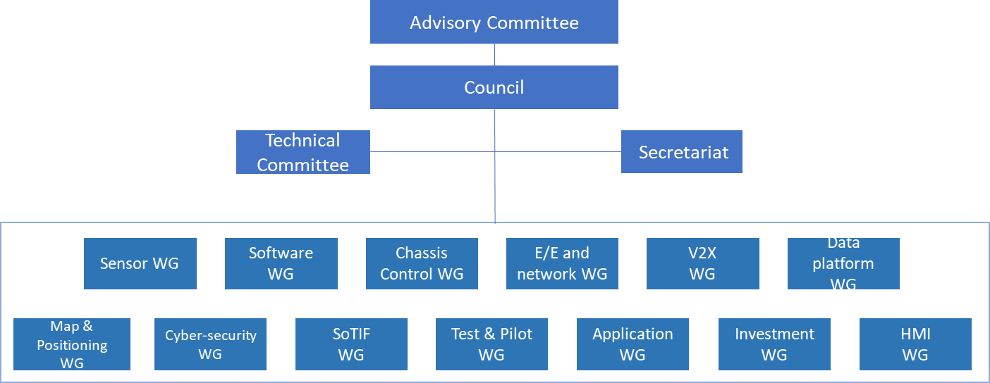
Figure 1 CAICV org. architecture
On standard front, CAICV works on ICV related standards, including autonomous, perception, vehicle control, HD Map and positioning, V2X/cooperative vehicle and infrastructure system, FuSa/SoTIF, vehicle E/E and in-vehicle network etc. Below figure gives an overall picture of the standards that CAICV works on.

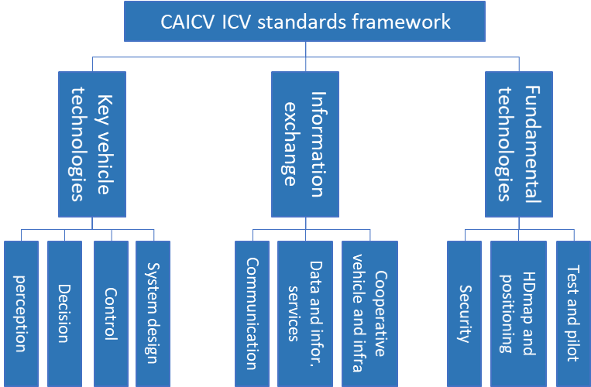
CAICV has been working on V2X related standards since 2017 right after it is established. The focus is the V2X related message set and application standards as well as related profile standards. Blow table gives a full list of the V2X standards that CAICV published as well as is working on.

Standard | Status | Note
T/CSAE 53-2020 Cooperative intelligent transportation system: vehicular communication application layer specification and data exchange standard phase I | Published | Phase I message set
T/CSAE 157-2020 Cooperative intelligent transportation system: vehicular communication application layer specification and data exchange standard phase II | Published | Phase II message set
T/CSAE 158-2020 Data exchange standard for high level automated driving vehicle based on cooperative intelligent transportation system | Published | Message set for L4/5 autonomous driving
T/CSAE 159-2020 LTE-based vehicular communication - direct communication system roadside unit technical requirements | Published | RSU message transmission profile
Code of practice about test and evaluation for V2X system warning application function of intelligent and connected vehicles | Under drafting | V2X application test
Profiles for C-V2X certificates in security credential management system | Under drafting | C-V2X security profile

C-ITS (ITS) – HW/CATT/ZTE

NTCTM (National Technical Committee on Traffic Management of Standardization Administration of China) – HW

Future Forum –QC/CU?

TIAA –QC/CT?

Summary and Proposal
[Editor’s note: This section summarizes the standards/specifications status in China and give proposal for 5GAA e.g. Standard collaboration and mutual recognition]

